**DEPARTMENT OF INFORMATION SCIENCE ENGINEERING DAYANANDA SAGAR COLLEGE OF ENGINEERING** (An Autonomous Institute affiliated to VTU, Belagavi, Approved by AICTE & ISO 9001:2008 Certified) Accredited by National Assessment & Accreditation Council (NAAC) with ‘A’ grade, Accredited by NBA

Shavige Malleshwara Hills, Kumaraswamy Layout, Bengaluru-560078.

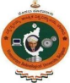

**Web Development Lab (22ISL473)**

**Mini Project**

on

**“AI CHATBOT”**

Submitted By

**Aditya Singh 1DS22IS008**

**Akash GS 1DS22IS010**

**Under the Guidance of**

**Dr. Radhika T V, Dr. Latha A P & Mrs.Krupashankari S S**

**Assistant Professor**

**Dept. of ISE, DSCE**

# DAYANANDA SAGAR COLLEGE OF ENGINEERING

## Shavige Malleshwara Hills, Kumaraswamy Layout

**Bangalore-560078**

**Department of Information Science and Engineering**

**2023-2024**

# CERTIFICATE

This is to certify that the Mini Project Work entitled **“AI Chatbot”** is a bonafide work carried out by Aditya Singh (1DS22IS008), Akash GS (1DS22IS010), in partial fulfillment for the 4th semester of Bachelor of Engineering in Information Science & Engineering of the Visvesvaraya Technological University, Belgavi during the year 2023-2024. The Web Development Lab Mini Project(22ISL473) report has been approved as it satisfies the academic requirements prescribed for the Bachelor of Engineering degree.

|  |  |
| --- | --- |
| **Signature of Examiner 1** | **Signature of Examiner 2** |
|  |  |

**CONTENTS**

**1. ABSTRACT**

**2. INTRODUCTION**

**2.1 Overview**

**2.2 Problem Statement**

**2.3 Objectives**

**3. Use Case Diagram**

**4.**  **Implementation & Application Code**

**5. Output or Results**

**6. Appendix & References**

**ABSTRACT**

The AI-ChatBot project is an innovative application designed to interact with users through natural language processing and provide intelligent responses to their queries. Utilizing Google Generative AI, this chatbot leverages advanced machine learning algorithms to understand and generate human-like text based on user input. The primary goal of this project is to create an engaging, efficient, and reliable chatbot that can handle a variety of user interactions, from answering questions to performing simple tasks.

This project is developed as part of the Web Development Lab (22ISL473) course, highlighting the integration of web technologies and artificial intelligence. The chatbot interface is built using HTML, CSS, and JavaScript, ensuring a user-friendly and visually appealing experience. The back-end communication with the AI model is facilitated through API calls to Google Generative AI services, which process the user input and return contextually relevant responses.

The AI-ChatBot project addresses several key objectives:

**1.** To design and implement a web-based chatbot that can interact with users in real-time.

**2.** To integrate Google Generative AI for natural language processing and response generation.

**3.** To ensure the chatbot can handle diverse queries accurately and efficiently.

**4.** To provide a seamless and intuitive user interface for easy interaction.

Throughout the development process, various challenges were encountered, such as managing API calls, ensuring data security, and optimizing response time. These challenges were addressed through robust coding practices, secure handling of API keys, and efficient front-end design.

The outcome of this project is a functional AI-ChatBot that demonstrates the potential of integrating AI with web development. It serves as a foundational platform for future enhancements, such as incorporating more complex AI models, expanding the chatbot’s knowledge base, and improving user interaction through additional features like voice recognition and multi-language support. This project not only showcases technical skills but also emphasizes the importance of AI in enhancing user experiences in web applications.

**INTRODUCTION**

The AI-ChatBot project represents a significant leap in the integration of artificial intelligence with web development, aimed at providing an intelligent, interactive, and user-friendly platform for human-computer communication. In the age of rapid technological advancement, chatbots have emerged as essential tools across various domains, from customer service to personal assistance. The AI-ChatBot harnesses the power of Google Generative AI to deliver a sophisticated conversational agent capable of understanding and responding to user queries with remarkable accuracy and relevance.

The primary motivation behind this project is to explore and implement advanced AI techniques in a web-based environment, thereby enhancing the user experience and demonstrating the practical applications of AI in everyday scenarios. The project is part of the Web Development Lab (22ISL473) curriculum, which emphasizes the importance of combining theoretical knowledge with hands-on practice to solve real-world problems.

The core functionality of the AI-ChatBot lies in its ability to process natural language input from users, analyze the context, and generate appropriate responses. This is achieved through the integration of Google Generative AI, which utilizes state-of-the-art machine learning models to interpret and produce human-like text. The project also focuses on creating an intuitive and aesthetically pleasing user interface using HTML, CSS, and JavaScript, ensuring that users can interact with the chatbot effortlessly.

The objectives of the AI-ChatBot project include designing a responsive and efficient chatbot, integrating reliable AI technologies, and ensuring robust performance across various user interactions. The project aims to address common challenges in chatbot development, such as managing natural language processing, ensuring data security, and maintaining quick response times.

In conclusion, the AI-ChatBot project not only showcases the potential of AI in enhancing web applications but also serves as a practical demonstration of the seamless integration of AI with web technologies. This project lays the groundwork for future developments, including more advanced AI capabilities, expanded functionality, and broader applications in diverse fields.

**2.1 Overview**

The AI-ChatBot project aims to create a sophisticated conversational agent that leverages Google Generative AI to facilitate natural language interactions with users. Designed as part of the Web Development Lab (22ISL473), this project integrates advanced AI capabilities with web technologies to deliver a user-friendly chatbot. The chatbot interface, built using HTML, CSS, and JavaScript, ensures a seamless and visually appealing user experience.

The core functionality revolves around processing user inputs, analyzing context, and generating accurate responses through API calls to Google's AI services. This project not only demonstrates the practical application of AI in web development but also highlights the importance of interactive technologies in enhancing user engagement.

The AI-ChatBot serves as a versatile platform, capable of handling diverse queries and performing various tasks, showcasing the potential of integrating AI into everyday web applications.

**2.2 Problem Statements**

In today's digital age, efficient and accurate communication between users and digital platforms is crucial. Traditional chatbots often struggle with understanding and generating contextually relevant responses, leading to user frustration and decreased engagement. The AI-ChatBot project addresses these challenges by implementing a sophisticated AI-powered chatbot that utilizes Google Generative AI. The problem lies in creating a chatbot that can seamlessly interpret natural language, understand context, and provide intelligent responses in real-time. Additionally, ensuring a user-friendly interface and maintaining robust performance under varying loads are significant challenges. This project aims to overcome these issues by integrating cutting-edge AI technologies with web development practices, thus enhancing user interaction and satisfaction through an intelligent and responsive chatbot.

**2.3 Objectives**

The primary objectives of the AI-ChatBot project are to design and implement an intelligent, web-based chatbot that provides accurate and contextually relevant responses to user queries.

Key objectives include:

**1.** Integrating Google Generative AI for advanced natural language processing and response generation.

**2.** Developing a user-friendly interface using HTML, CSS, and JavaScript to ensure seamless interaction.

**3.** Ensuring the chatbot can handle a wide range of queries efficiently and accurately.

**4.** Addressing common challenges in chatbot development, such as managing API calls, ensuring data security, and optimizing response times.

**5.** Providing a robust platform for future enhancements, such as incorporating voice recognition, multi-language support, and expanding the chatbot's knowledge base.

**Use Case Diagram**

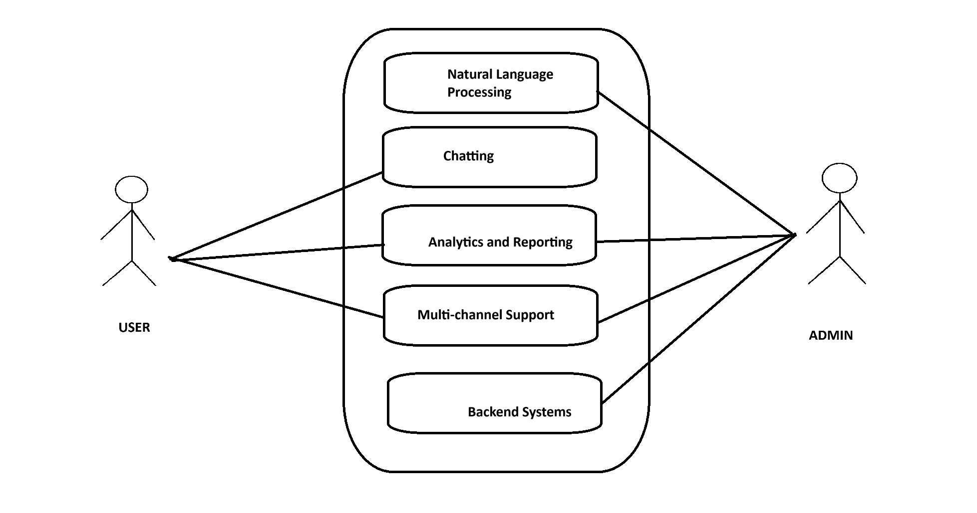

**Implementation & Application Code**

**4.1 Front-End Design**

The front-end of the AI-ChatBot is designed using HTML, CSS, and JavaScript. HTML provides the structure of the chat interface, including input fields and message display areas. CSS styles the elements to ensure a clean and user-friendly layout, while JavaScript handles user interactions and API calls.

**4.2 Back-End Integration**

The back-end integration involves setting up API calls to communicate with the Google Generative AI service. This setup allows the chatbot to send user queries to the AI model and receive intelligent responses. It's crucial to securely handle API keys and user data to maintain privacy and security.

**4.3 AI Model Integration**

Integrating the Google Generative AI model requires configuring API endpoints and managing response data effectively. This involves sending user messages to the AI model via HTTP POST requests and parsing the AI-generated responses for display in the chat interface.

**4.4 User Interaction**

Smooth user interaction is ensured by handling user inputs, displaying messages in real-time, and managing the chat flow. JavaScript functions manage user input validation, message display, and API interactions asynchronously to maintain a responsive user experience.

These components work together to create a functional and interactive AI-ChatBot. Each part plays a crucial role in enabling seamless communication between users and the AI model, facilitating natural language processing and intelligent conversation handling.

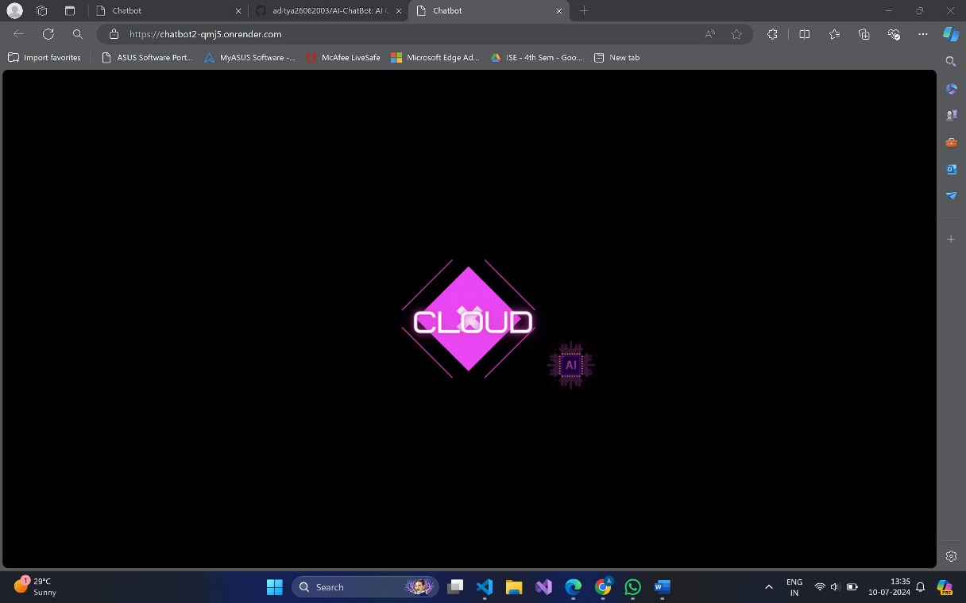**Output or Results**

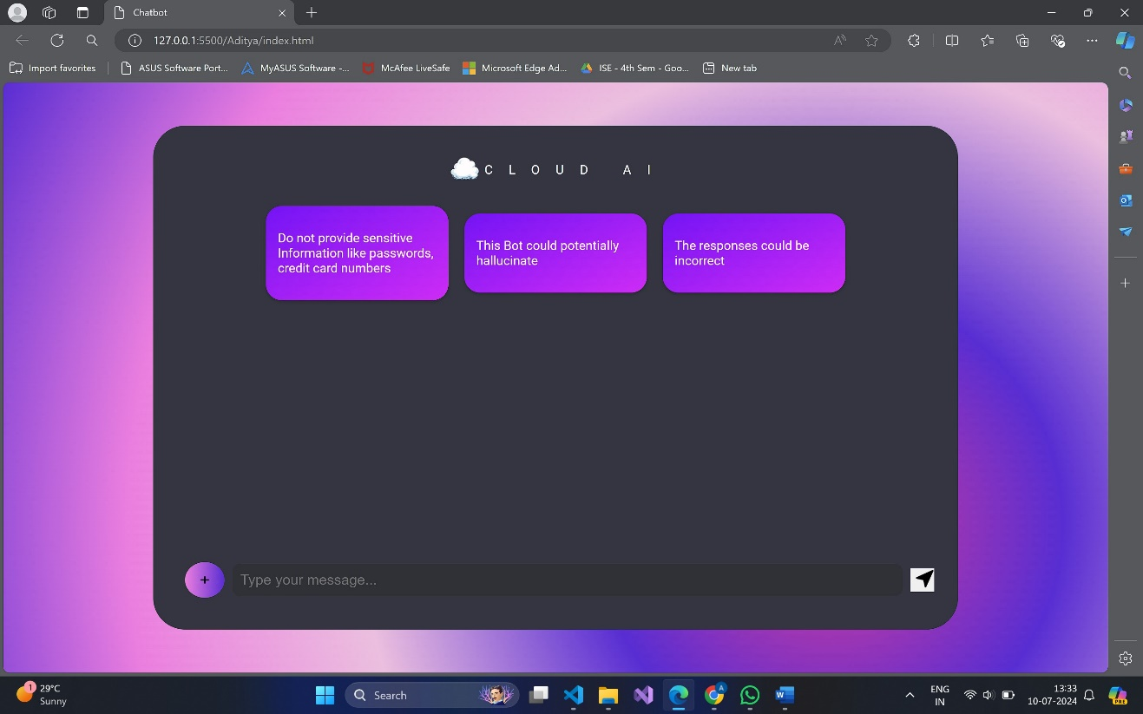

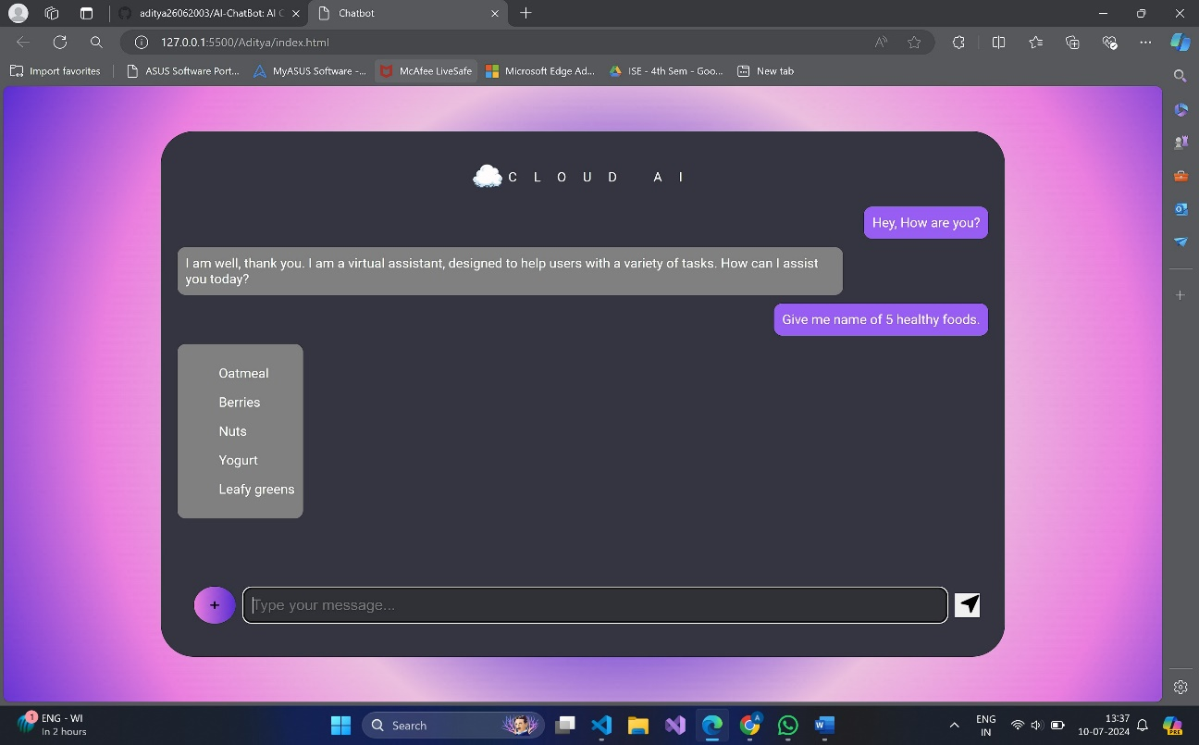

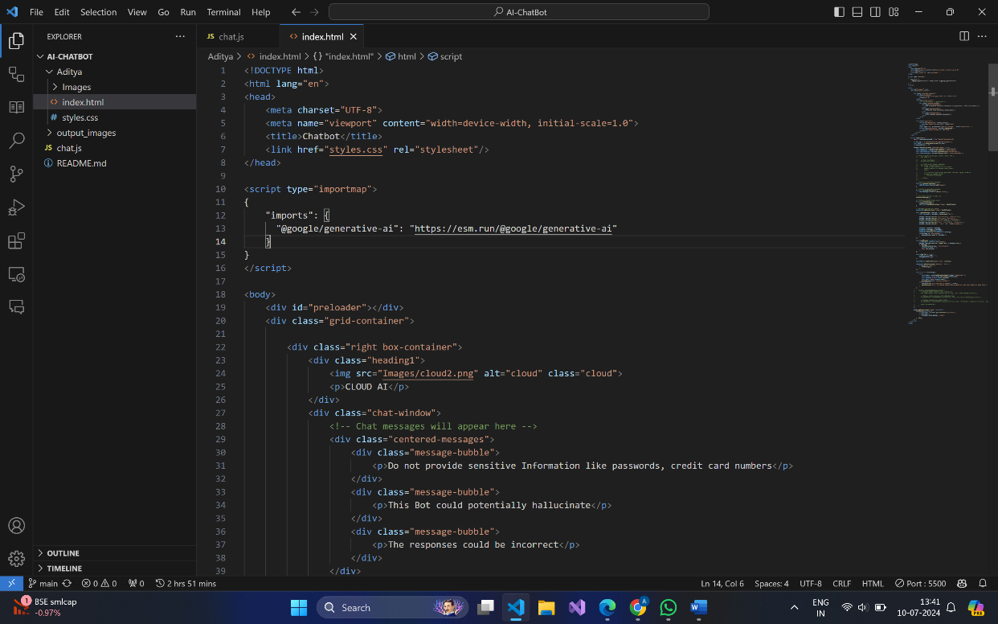

**Appendix & References**

**References**

**1.** Google Generative AI Documentation: Detailed documentation on how to integrate and use Google's AI models.

**2.** MDN Web Docs: Comprehensive resource for HTML, CSS, and JavaScript references.

**3.** W3Schools: Tutorials and references for web development technologies.

**4.** Stack Overflow: Community-driven platform for troubleshooting and finding solutions to coding problems.

**5.** GitHub: Repository hosting service used for version control and collaboration.

**6.** Gemini API Documentation: Documentation provided by the API service for integrating the chatbot with the AI model.

**Research Papers**

**1**. Vaswani, A., Shazeer, N., Parmar, N., Uszkoreit, J., Jones, L., Gomez, A. N., Kaiser, Ł., & Polosukhin, I. (2017). Attention is all you need. In Advances in neural information processing systems (pp. 5998-6008).

**2.** Radford, A., Wu, J., Child, R., Luan, D., Amodei, D., & Sutskever, I. (2019). Language Models are Unsupervised Multitask Learners. OpenAI.

**3.** Devlin, J., Chang, M. W., Lee, K., & Toutanova, K. (2019). BERT: Pre-training of Deep Bidirectional Transformers for Language Understanding. In NAACL-HLT (pp. 4171-4186).